Answers 3.5

* Film title contains the word *Uptown* in any position

SELECT title, film_id, description FROM film WHERE title LIKE '%Uptown%'

4 Films total.

* Film length is more than 120 minutes and rental rate is more than 2.99

SELECT title, film_id, description FROM film WHERE length < 120 AND rental_rate > 2.99

* Rental duration is between 3 and 7 days (where 3 and 7 aren’t inclusive)

SELECT title, film_id, description FROM film WHERE rental_duration BETWEEN 3 AND 7

* Film replacement cost is less than 14.99

SELECT title, film_id, description, replacement_cost FROM film WHERE replacement_cost < 14.99

* Film rating is either PG or G

SELECT title, film_id, description, rating FROM film WHERE rating IN ('PG','G')

Step 3

Check Excel Sheet.

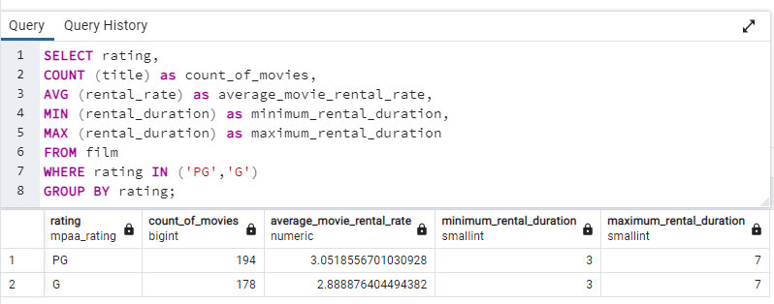Step 5

SELECT rating,

COUNT (title) as count_of_movies,

AVG (rental_rate) as average_movie_rental_rate,

MIN (rental_duration) as minimum_rental_duration,

MAX (rental_duration) as maximum_rental_duration

FROM film

WHERE rating IN ('PG','G')

GROUP BY rating;